**Machine Learning-1**

KNN:

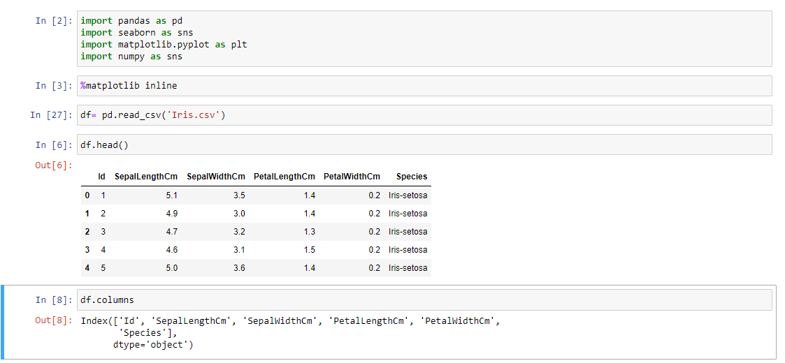

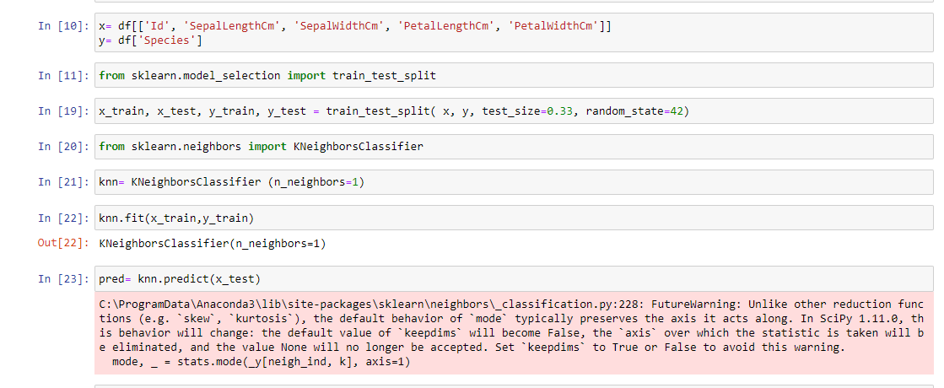

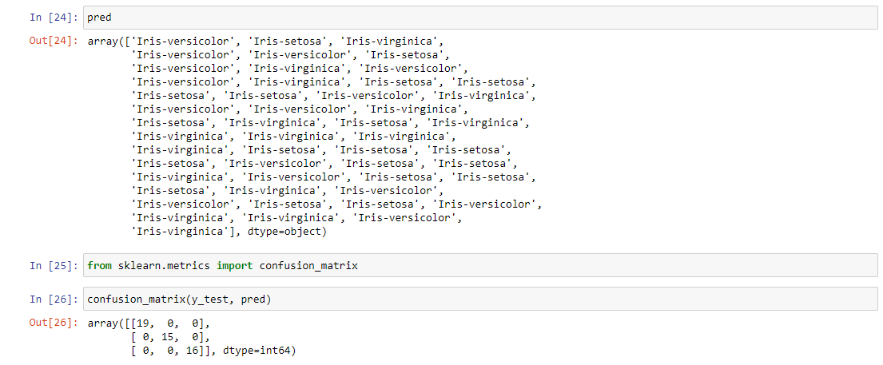

INTERPRETATION:

In this KNN analysis the true positive is 50 which brings the accuracy of 100%

DECISION TREE:

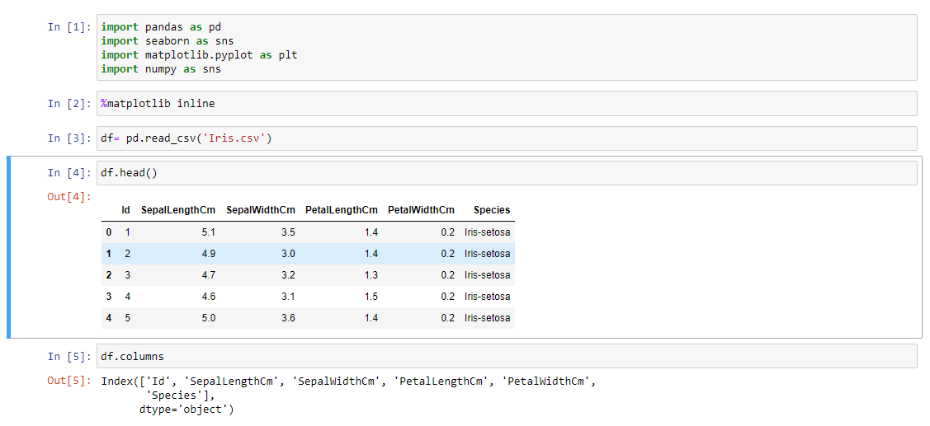

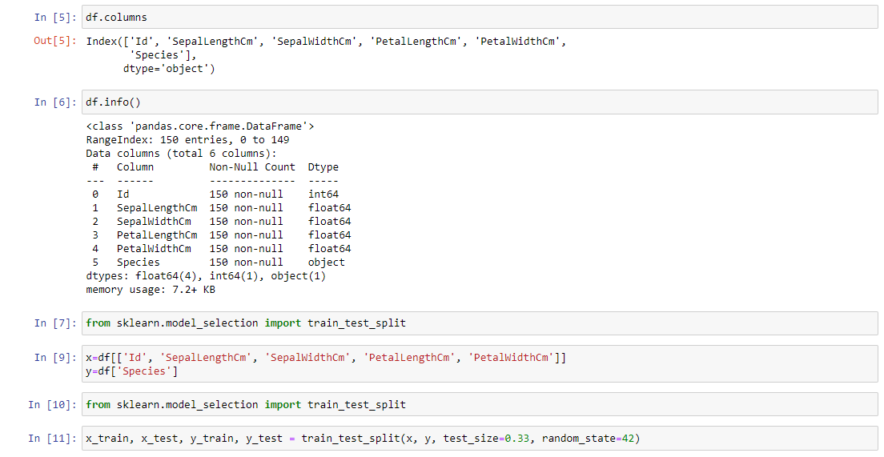

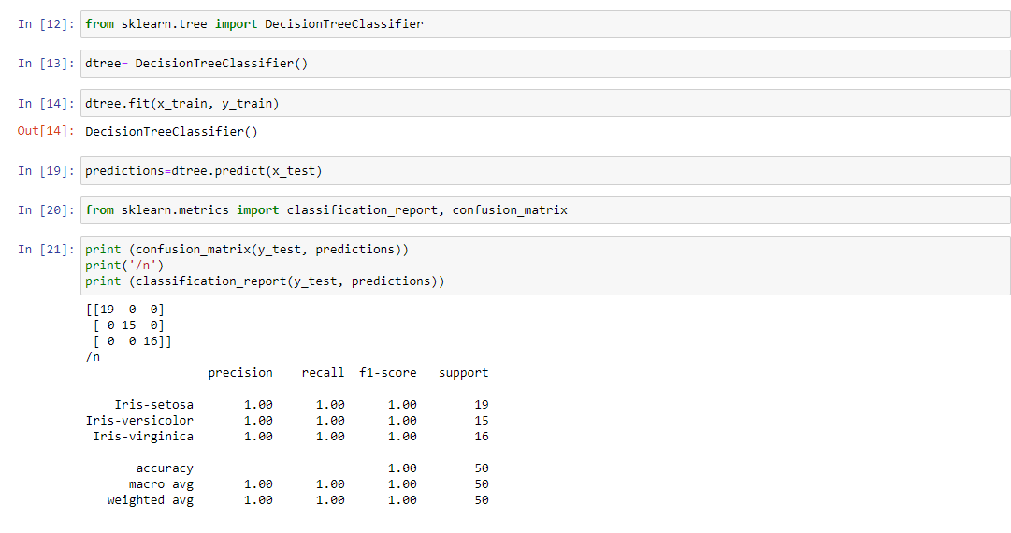

INTERPRETATION:

In this decision tree analysis the true negative is 19 and true positive is 40 which brings the accuracy 98%